Eskom Kimberley Strengthening Phase 4 Project: MANGANORE-FERRUM
Photos of the macro study area
Detail site photos are provided in the specialists reports

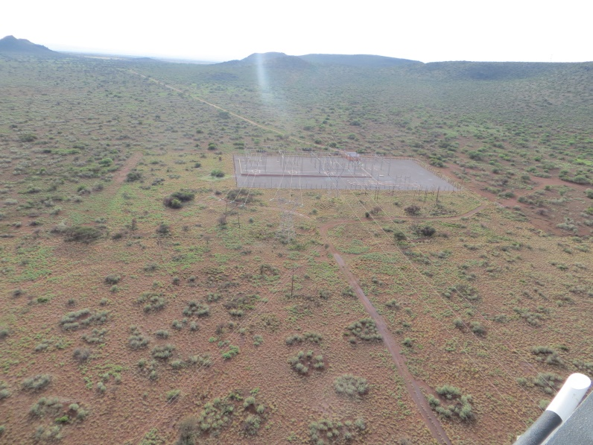 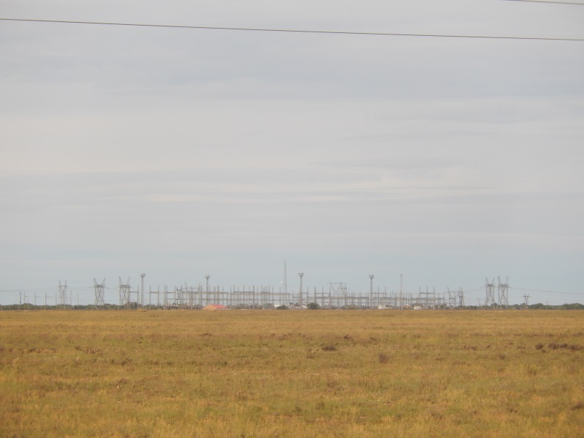The Manganore Distribution Substation

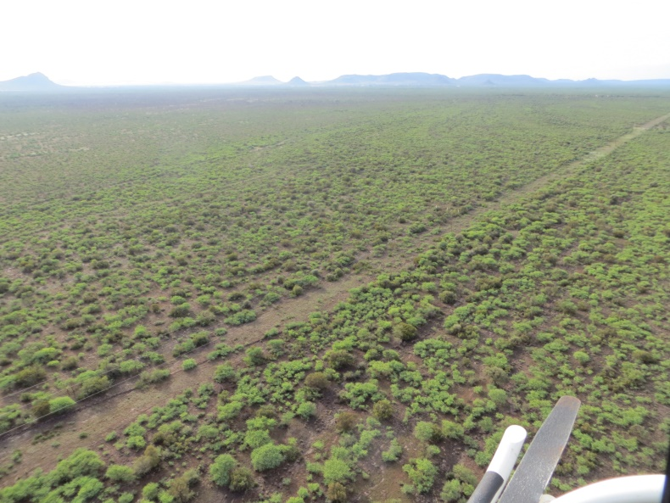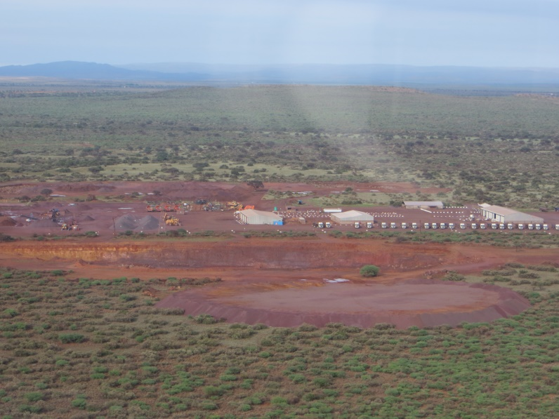
An existing power line route within the landscape Mining infrastructure

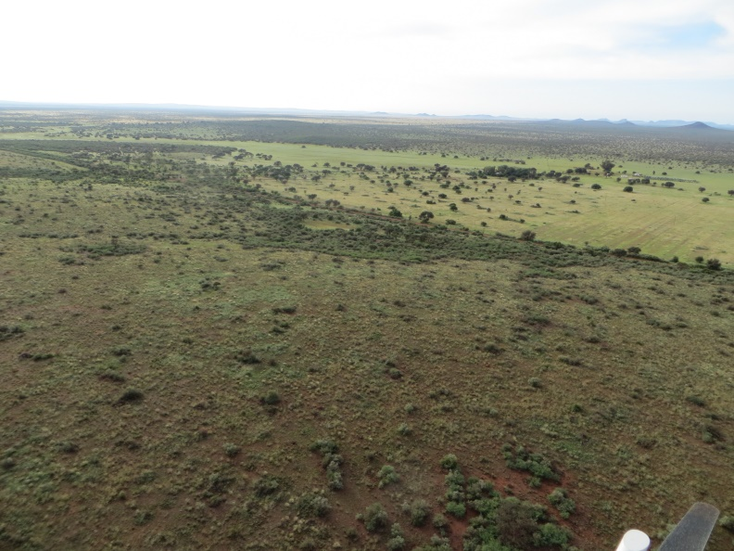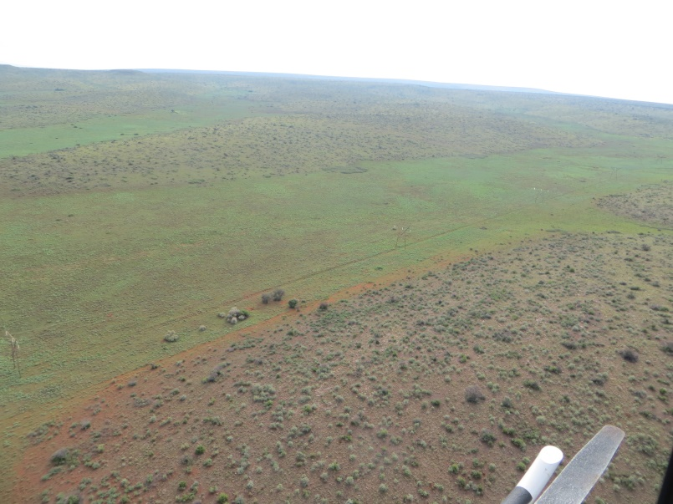
The Ga-Mogara River View of the pans that occur to the east of the study area and are typically associated with the Ga-Mogara River System (note the existing Eskom power line within the pans)

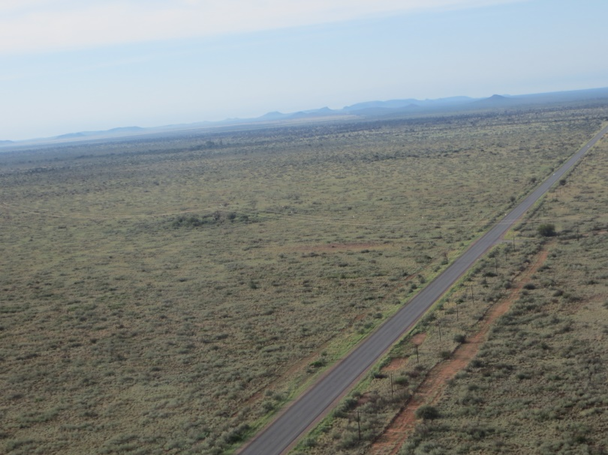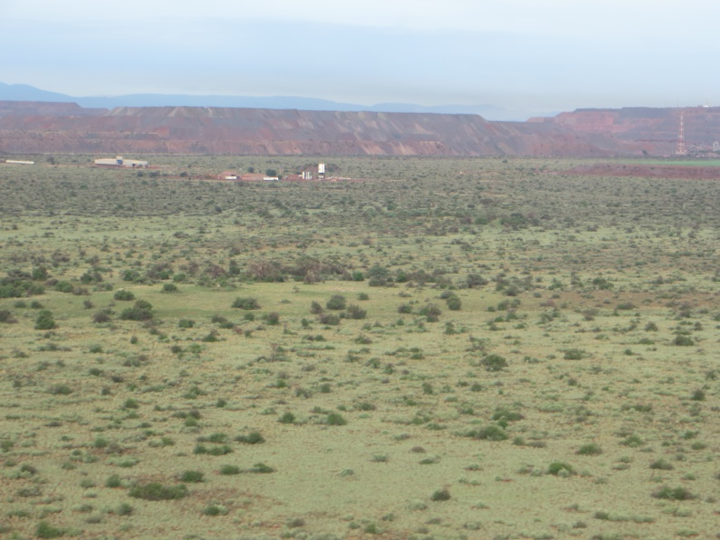
The N14 south of Kathu A mine and mine heaps within the study area

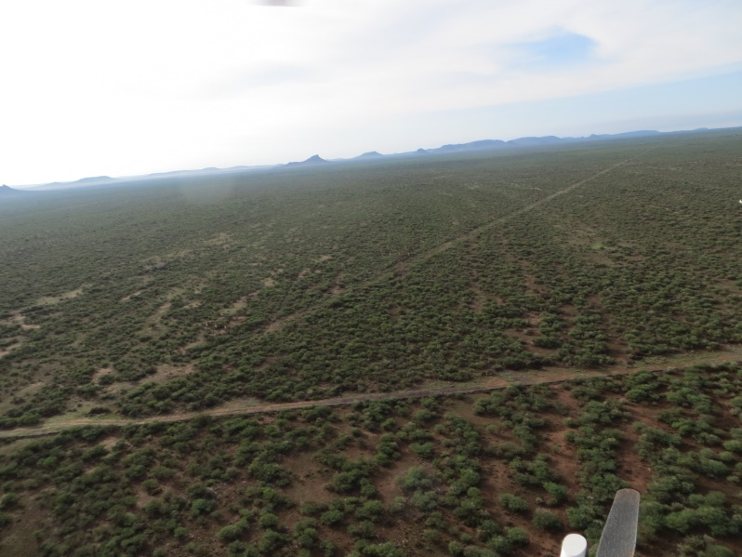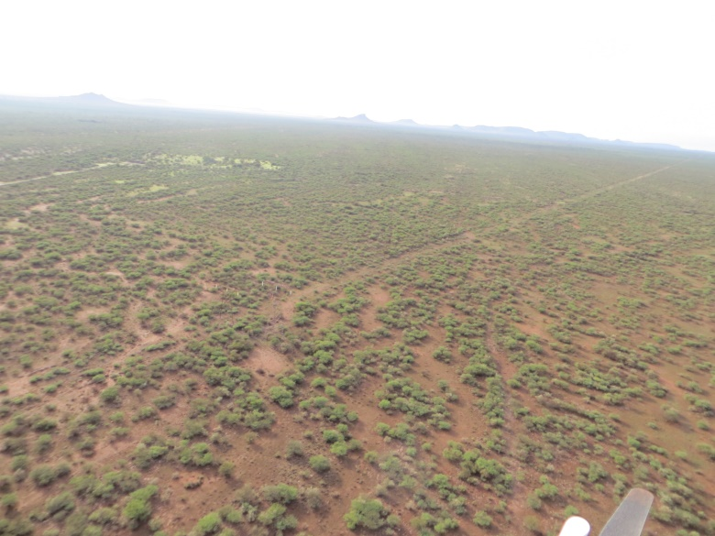
Natural landscapes within the study areas, with farm roads, fences and existing Eskom servitudes clearly visible

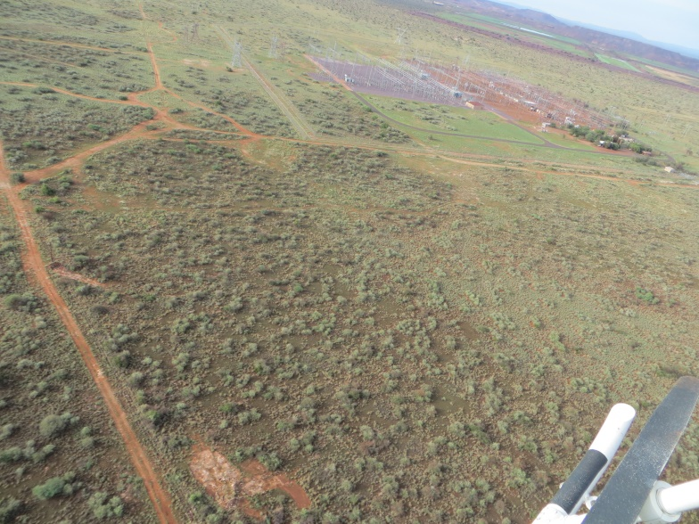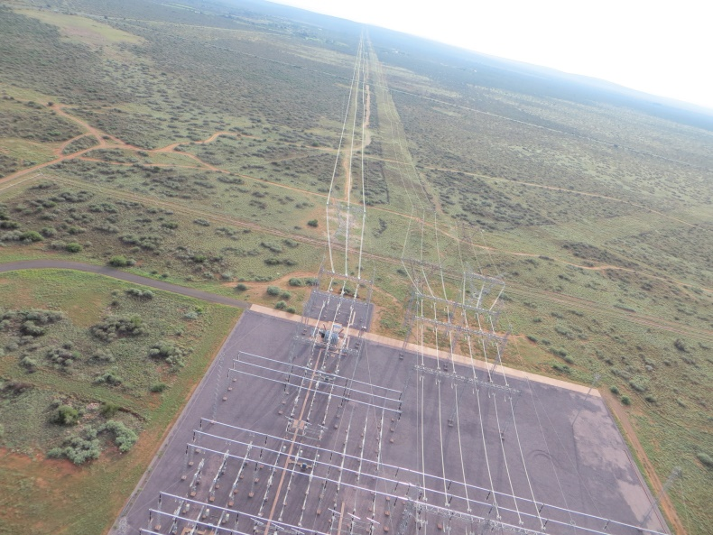
Ferrum Substation and surrounding area

